4379363 - Consolidation - Roll Forward all linked engagements
[EM] Consolidation - Roll Forward all linked engagements at the same time (Epic 4379363)1. Customer Problemforward each engagement sequentially creates delays and errors across multi-tier structures.

2. Customer Researchneed to discover all descendants and roll them forward from the parent.

This capability was requested as feedback from an enterprise-level accounting firm, reflecting needs observed in large multi-entity audit workflows.
We are also building this to achieve competitive parity with Wolters Kluwer ProSystem fx Engagement, which offers similar functionality.

3. Our SolutionRoll Forward wizard shows entire hierarchy with selection.

- Dependency order and validations, consolidated logs.
Dependencies: roll forward services, hierarchy resolver.

4. Product MetricsTime to roll forward 3-tier, 8-engagement structure: -50%.

- Post-roll exceptions due to sequencing: <2%.
Appendix: Child Features4379376 Identify all child engagements and show in roll forward wizard
Appendix: LinksHYPERLINK "https://dev.azure.com/tr-tax/TaxProf/_workitems/edit/4379363"Open Epic 4379363

Appendix: Quick prototype

Figure: PDF page 1
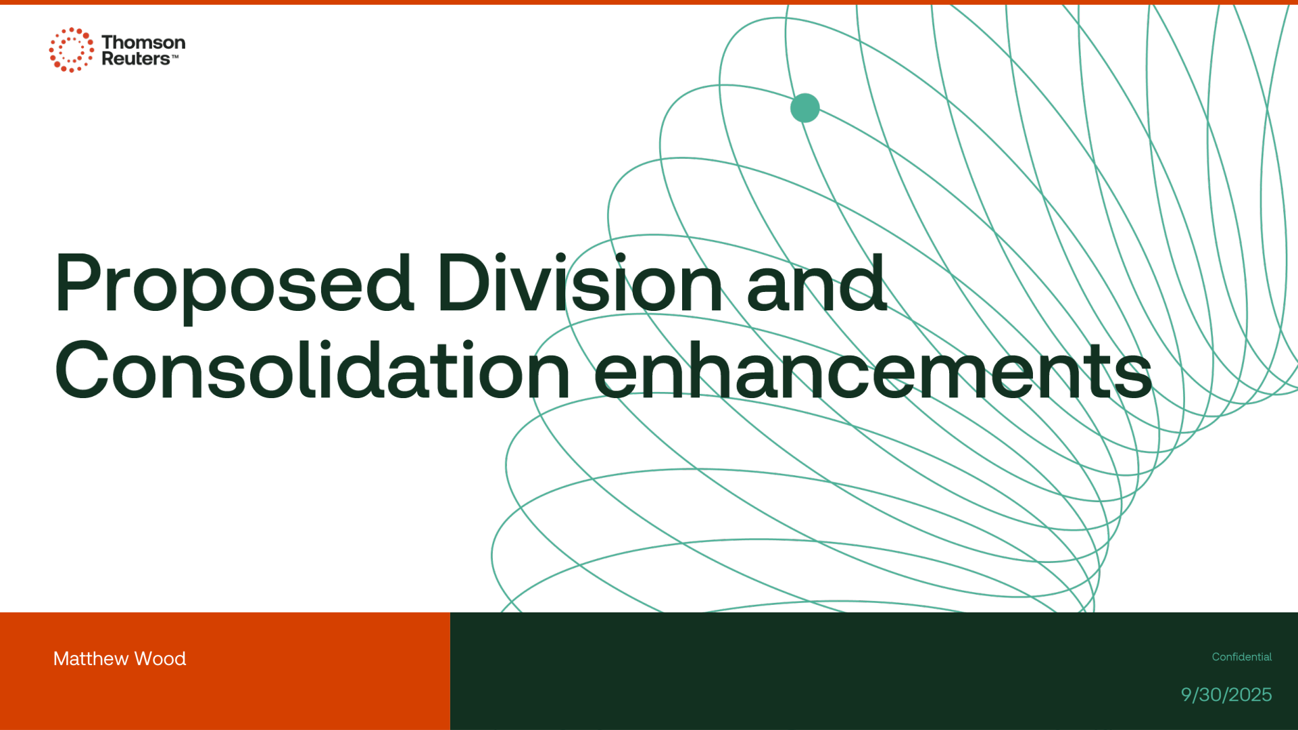

Appendix: Links
ADO Epic Link: https://dev.azure.com/tr-tax/TaxProf/_workitems/edit/4379363

